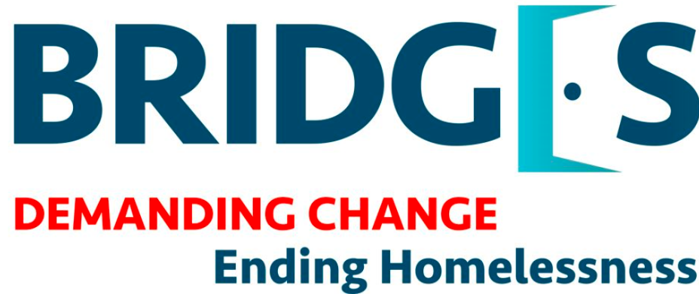

**Position:** Program Manager

**Location:** Newark, New Jersey

**# of Openings:** 2

**Who are we**

Bridges is a rapidly expanding, leading non-profit organization specializing in ending homelessness. Bridges began as an outreach organization feeding the homeless. Now these outreach services act as a gateway to forming relationships with our clients, for Bridges to offer individual case management services focusing on health, housing and independence. This unique offering has contributed to our remarkable growth and is the differentiator that sets Bridges apart from other organizations. Our team has worked hard to build a reputation of meeting people where they are physically and mentally, by consistently and effectively providing solutions for housing, by growing our impact in Essex and Union counties, by continuously improving, and by focusing on exceeding the expectations of our clients, our service partners, our volunteers, and donors. If you have a passion to serve people experiencing homelessness, join Bridges as we strive to give all of our clients a front door of their own.

**Who are we seeking**

We are currently looking for an experienced results driven program leader who has worked in the homeless sector. A proactive individual with excellent leadership, communication and organizational skills. Our Program Manager needs to have created and executed case plans to help homeless individuals increase their independence and long-term sustainability, as well as successfully lead case collaborative meetings with a team of licensed case managers working collectively towards innovative solutions for programmatic shortcomings and client barriers. This position interacts with both internal clients and external clients, as well as outside agencies.

**What will you do**

The Bridges Program Manager is responsible for preserving and cultivating the essence of Bridges Outreach Project Connect drop-in centers:

* Supervise case managers, outreach workers, support staff and interns to ensure quality of case management services
* Train staff
* Maintain an active caseload
* Responsible for data control and statistical analysis
* Manage front office operations and administrative tasks
* Manage office supply, budgets and reconciliations
* Coordinate organizational programs/events
* Reconcile client conflicts
* Work with Human Resources department to Interns
* Process client birth certificate applications
* Interface with office of Vital Statistics on Birth Certificate Orders
* Communicate with Bridges Operations Team regarding clothing and food distribution schedules
* Take part in other duties and projects, as assigned

**What are the requirements**

* Degree in Social Work
* 2 years experience as a Social Worker
* 4 years of experience managing and leading a team of social workers
* Notary or eligibility to obtain status

**Additional Qualifications, Strengths and Skills**

* Experience working in an environment with high client volume
* Understanding of Utilizing a trauma-informed approach
* Crisis de-escalation certification (Plus)
* LCADC (Plus)
* LSW (Plus)
* Bilingual (English/Spanish) (Plus)

**Internal Information**

**Job Type:** Full-time

**Salary:** $60,000-70,000

**Home Office:**  Newark, NJ

**Schedule:** 40 hours   
Monday to Friday   
Weekend availability a plus

**Benefits**: Medical  
Dental  
Vision  
Life Insurance  
Ancillary Benefits  
401K with match  
Paid Vacation Time